- Angles and Plane Figures
1. The sum of angles of a triangle is given by the expression (2a+b)⁰ while that of a quadrilateral is given by 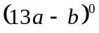. Calculate the values of a and b (4 mks)
2. The figure below represents a quadrilateral ABCD. Triangle ABX is an equilateral triangle. If 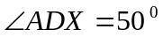, find  with 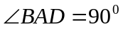 (2 mks)
D
C
B
A
X

3. Wanjiku is standing at a point P, 160m south of a hill H on a level ground. From point P she observes the angle of elevation of the top of the hill to be 67⁰
(a) Calculate the height of the hill (3 mks)
(b) After walking 420m due east to the point Q, Wanjiku proceeds to point R due east of Q, where the angle of elevation of the top of the hill is 35⁰. Calculate the angle of elevation of the top of the hill from Q (3 mks)
(c) Calculate the distance from P to R (4 mks)
4. In the triangle XYZ below, find the angle ZXY. (3mks)
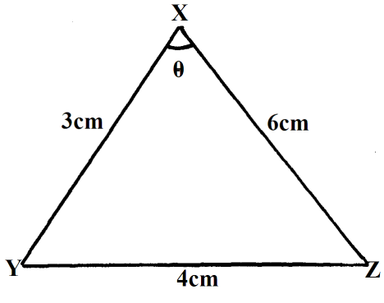
5. The exterior angle of a regular polygon is equal to one-third of the interior angle. Calculate the number of sides of the polygon and give its name. (4 mks)
6. In the figure below, lines AB and LM are parallel.
130⁰
A
B
L
M
y
z
x
83⁰

Find the values of the angles marked x, y and z (3 mks)
7. From points A and B on a level ground the angles of elevation to the top of the building are 24⁰ and 38⁰ respectively. If the distance between A and B is 47m and that of B from the foot of the building is X;
(a) Form an expression for the height of the building
(b) Calculate the height of the building
(c) Find the difference in the distance between the top of the building and points A and B
8. The angle of elevation of the top of the tower from the foot of a building is 63.51⁰. The angle of depression of the top of the building from the op of the tower is 18.43⁰. The building and the tower are 30m apart. Find
- The height of the tower (1mk)
- The height of the building (2mks)
9. The exterior angle of a regular polygon is an eighth of the interior angle. How many sides does the regular polygon have? (3 marks)
10. The sides of a parallelogram are 4cm by 5cm and its area is 12cm². Calculate its angles. (3 marks)
11. From a point 20m away on a level ground the angle of elevation to the lower window line is 27⁰ and the angle of elevation to the top line of the window is 32⁰. Calculate the height of the window.
(3 marks)
12. A regular polygon has its exterior angle 18⁰, and one of its sides 16cm. calculate its area.
(to 2 d.p) (3mks)
13. The angle of depression of a point A on the ground from the top of a post is 18⁰ and that of another point B on the same line as A nearer to the foot of the post is 25⁰. If A and B are 70m apart,
(a) Draw a sketch to represent positions of A and B. (2mks)
(b) Using your sketch calculate
(i) The height of the post from the ground level (ans 1 d.p) (6mks)
(ii) The distance of point A from the foot of the post. (2mks)
14. The figure below shows an irregular polygon PQRSTUVW.
Calculate the sum of all the interior angles in the figure below.
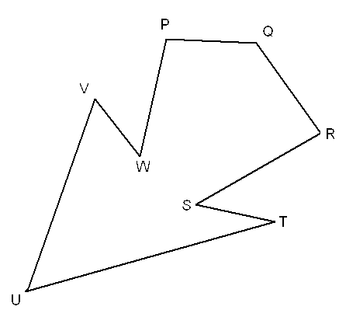

15. The angles of elevation from two points A and B to the top of a storey building are 48⁰ and 57⁰ respectively. If AB = 50m and the point A and B are opposite each other; Calculate;
a) the distance of point A to the building (2 mks)
b) the height of the building (2 mks)

